Author: Jovan Zlatanović

Activity Planner

Design specifications

# Problem domain

Organizing a persons daily activities with categories by allowing the user to keep track of their schedule and time.

## Target audience of interest:

* General public audience
* Employed people whose workflow bases around computers.

## Type of product:

* Desktop application tool

## Market standing:

* Free to use

# Solution domain

* Allow the creation of activities which can have subtasks.
* Keep track of those activities through time.
* Allow the user to customize their activity progress.
* Provide mental stimulation and motivation through notifications and status updates.

# Technical implementation

* Language: Java 17.0.2
* Graphics: JavaFX
* Selected IDE: IntelliJ Community 2021.3.2
* Project management: Github

# General product traits

* Main window
* Dynamic constant moving timeline with activity showcasing
* Tool menu for saving, editing, creating, and other options
* Auto-saving
* Desktop notifications
* Staying hidden when minimized

## Attachments:

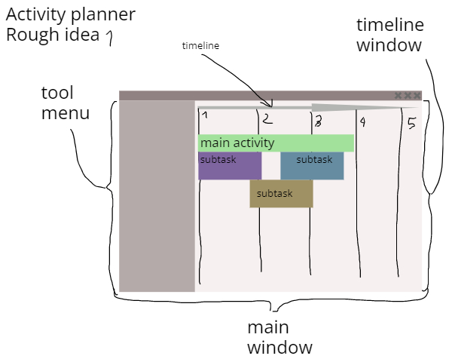

# Requirements model